# Logistic Regression (Module -9)

**Instructions**

Please share your answers filled inline in the word document. Submit Python code and R code files wherever applicable.

Please ensure you update all the details:

**Name: Batch Id:**  **Topic: Logistic Regression.**

1. **Business Problem**
   1. **Objective**
   2. **Constraints (if any)**
2. **Work on each feature of the dataset to create a data dictionary as displayed in the below image:**

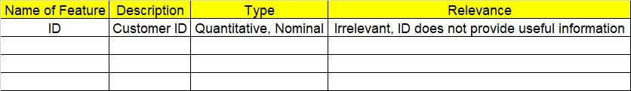

**2.1 Make a table as shown above and provide information about the features such as its Data type and its relevance to the model building, if not relevant provide reasons and provide description of the feature.**

**Using R and Python codes perform:**

1. **Data Pre-processing**

**3.1 Data Cleaning, Feature Engineering, etc.**

**3.2 Outlier Imputation**

1. **Exploratory Data Analysis (EDA):**
   1. **Summary**
   2. **Univariate analysis**
   3. **Bivariate analysis**
2. **Model Building**
   1. **Build the model on the scaled data (try multiple options)**
   2. **Perform Logistic Regression model.**
   3. **Train and Test the data and compare accuracies by Confusion Matrix, plot ROC AUC curve.**
   4. **Briefly explain the model output in the documentation.**



1. **Share the benefits/impact of the solution - how or in what way the business (client) gets benefit from the solution provided.**

# Note:

The assignment should be submitted in the following format:

* R code
* Python code
* Code Modularization should be maintained
* Documentation of the model building (elaborating on steps mentioned above)

**Standard Grading Guideline :**

Grade A: All assignments submitted correctly on Time (with all mentioned content like: python code, r code, documentation)

Grade B: All assignments submitted but post the due date. Or Partial assignments are submitted.

Grade C and Grade D: Partial assignments submitted with incorrect answers, or worked on only R or Python or not all the content is submitted.

Grade F: Partial assignments submitted with incorrect answers and not all the content is submitted.

Problem Statement: -

A psychological study has been conducted by a team of students at a University on married couples to determine the cause and effect on their married life and why they tend to have an extra marital affair, they have surveyed and collected a sample of data on which they would like to do further analysis to improve the relationship bond between couple, is it even possible to do so? Using your skills of Machine Learning apply Logistic Regression Model on the data and correctly classify whether a given person will have an affair or not given the set of attributes.

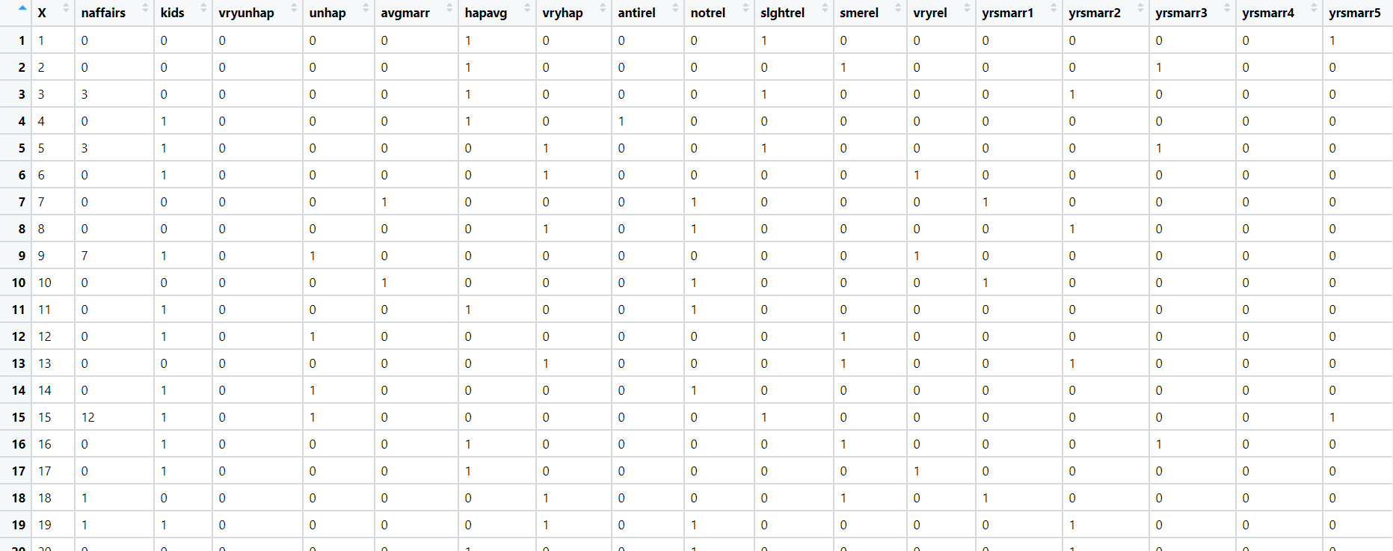Convert naffairs column to Discreet Binary before proceeding with algorithm.

**Problem Statement: -**

In this time and age of widespread internet usage, effective and targeted marketing play a vital role, a marketing company would like to develop their strategy by analyzing their customer data and how effectively they can do targeted marketing, for this historical data has been collected of users clicking on ad given different factors such as age, location, time of activity and more. Perform Logistic Regression on the given data and classify the user who click’s on ad’s and who does not click on ad.



**Problem Statement: -**

Prediction of election results has become trivial in these days, the outcome variable is (0/1) and the other factors that affect a candidate win or loss is amount of money spent, popularity and more. Perform Logistic Regression on the dataset and classify the candidates.

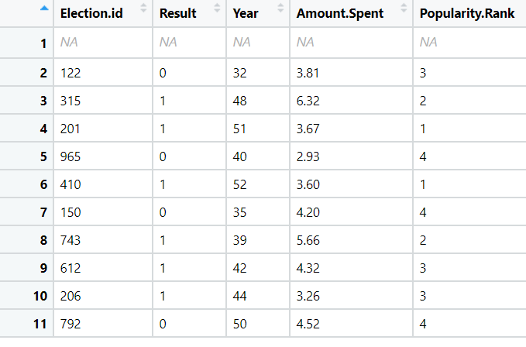

**Problem Statement:**

In Financial Institutions getting their customers to do a fixed deposit in the banks is a vital and at most important for the bank as they bank uses it and pays an interest amount to those deposited customers. To ask every customer for a term deposit is not viable as well as time consuming process, can you come up with a Logistic Regression model to predict customers who will do a term deposit or not.

The output variable in the dataset is Y which is discreet and binary. Snapshot of the dataset is given below**.**

